Guidence for PhD students using Studentweb 3

Stage 1: Log in to Studentweb

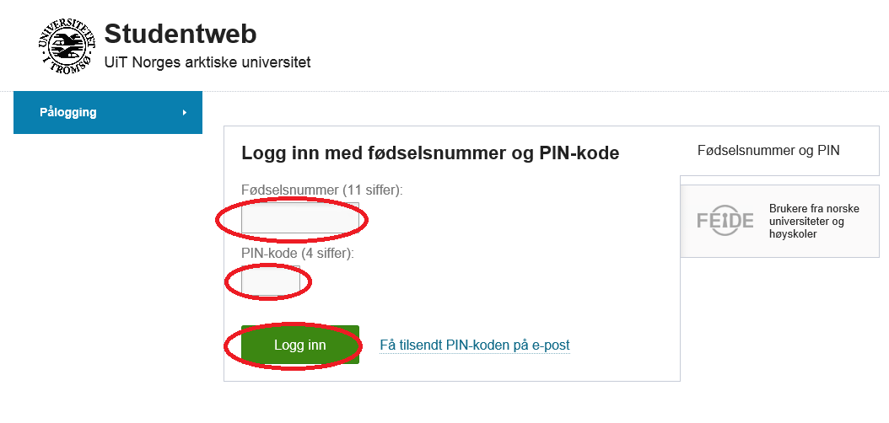

Log in with your 11-digit ID number and PIN-code, or

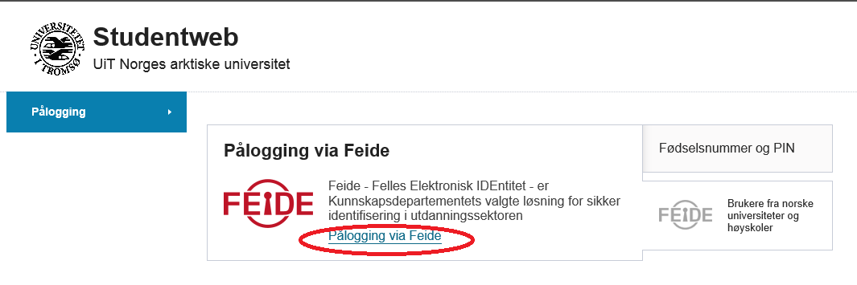

with your Feide-account.

Stage 2: Start progress report (confirming your education plan)

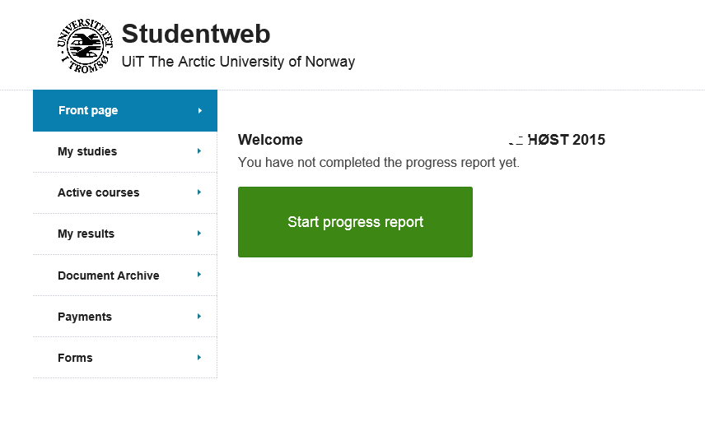

Accepting rights and obligations as a ph.d.-student

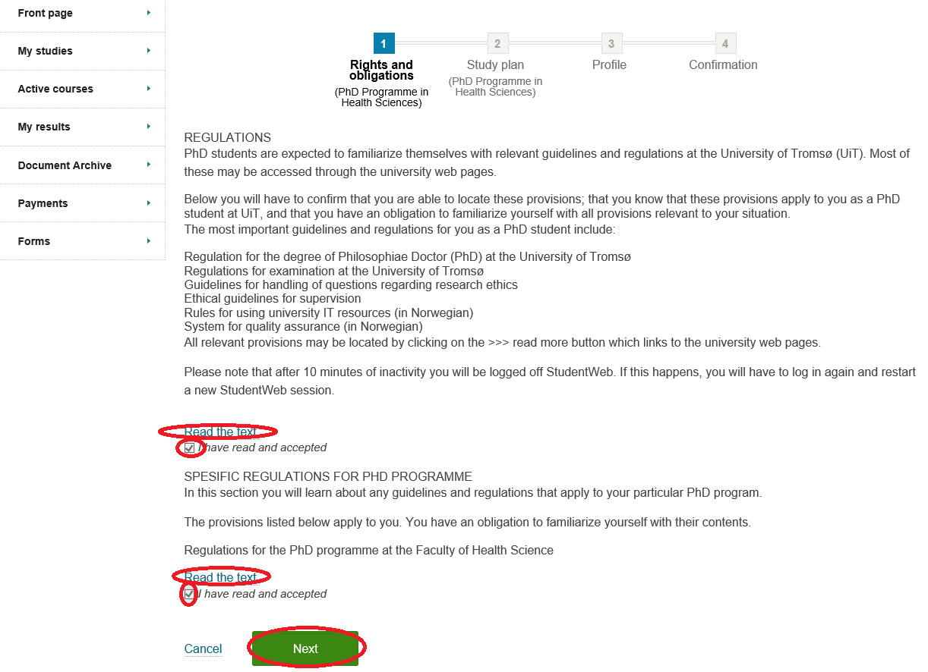

Read the regulations and accept them.

Click Next

Study plan – Detailed education plan

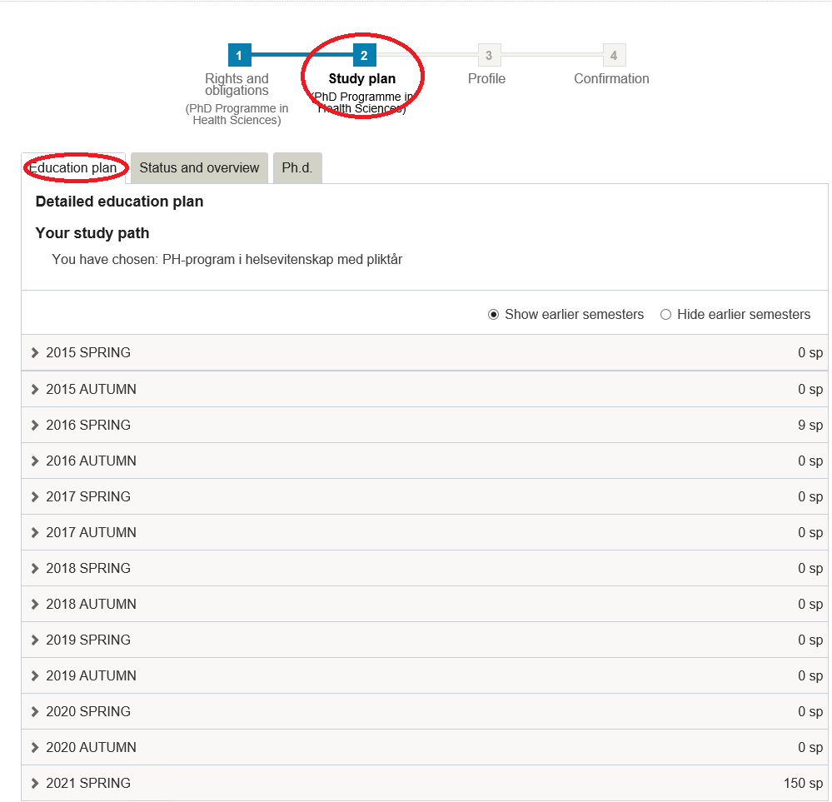

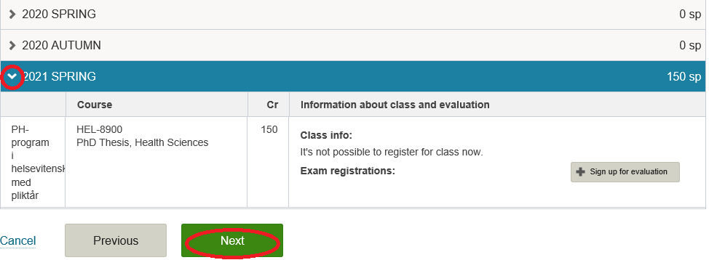

Click Next

Study plan – status and overview

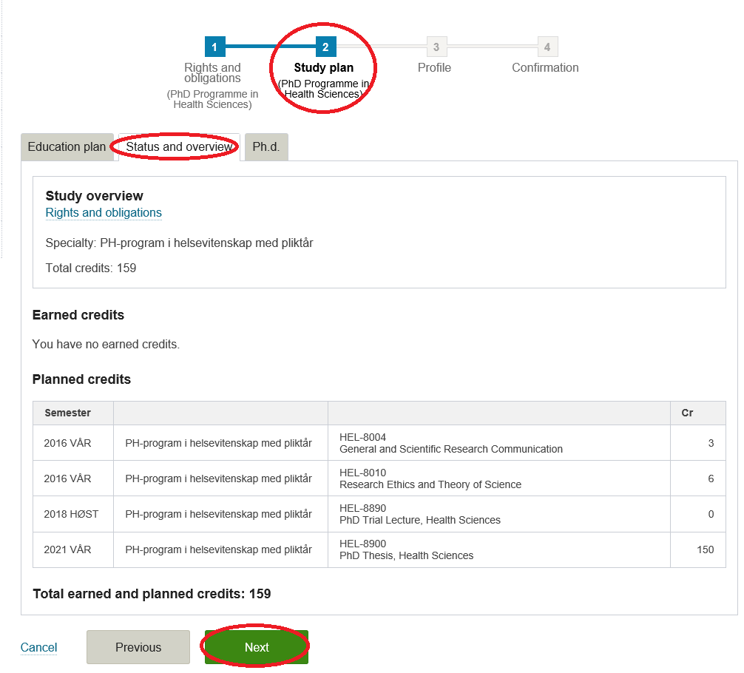

This shows all the courses registered in your education plan so far.

Click Next

Study plan – Ph.d.

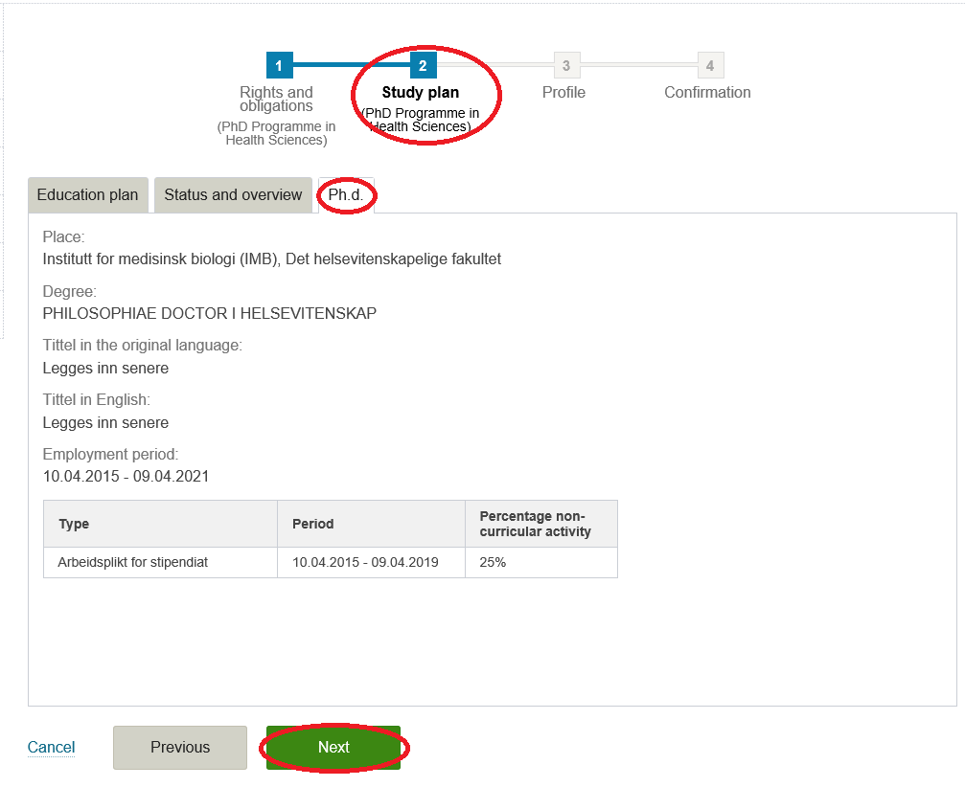

This gives an overview of your PhD agreement

Click Next

Study plan – Profile

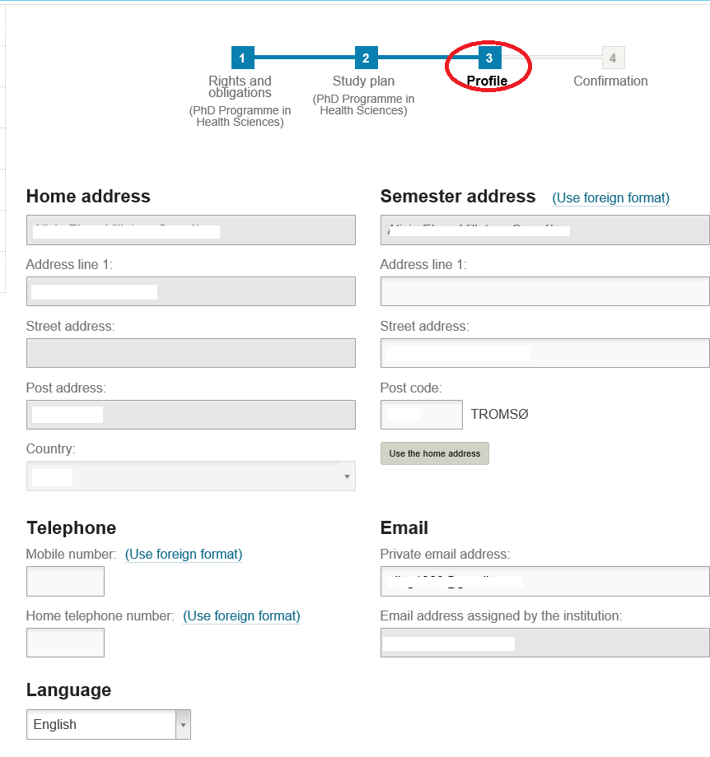

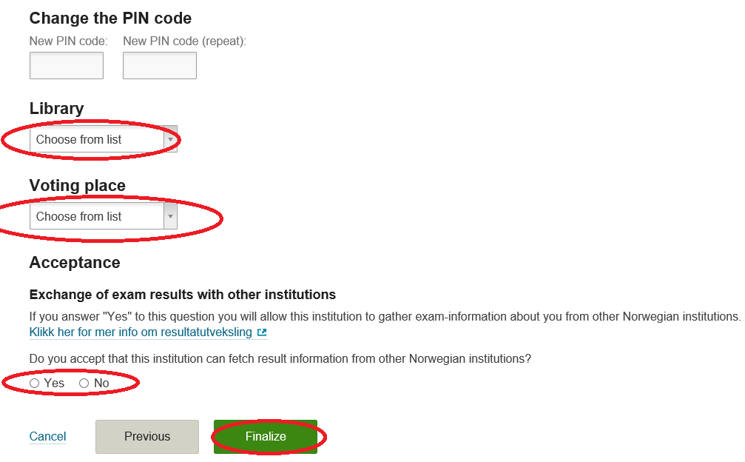

Choose your prefered library

Choose your voting place

Choose wether you accept that UiT can fetch result information from other Norwegan institutions.

Click Finalize

Stage 3: Registering for classes and exams

My studies

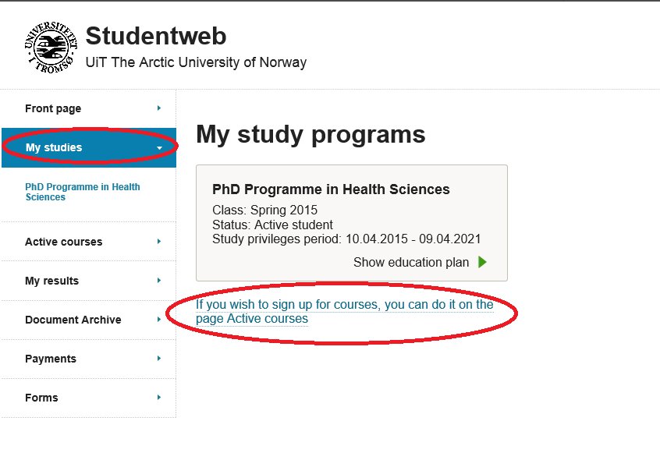

Active courses
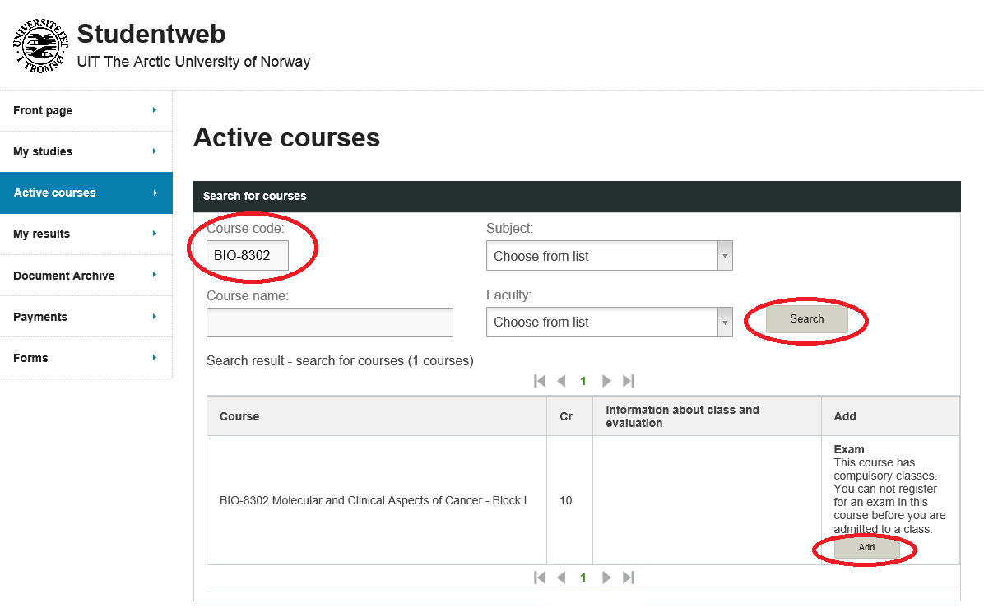

Course code: Three letters – four digits (BIO-8302)

- Click Search
- Click Add

Then the box Sign up for class appears

Sign up for class

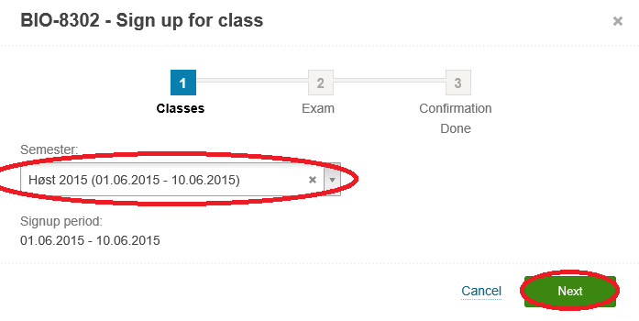
Click Next

Edit exam

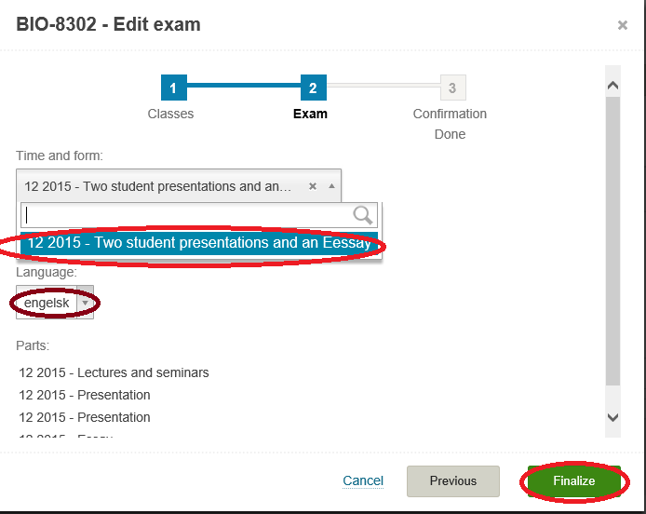

Confirmation signing up for classes and exams

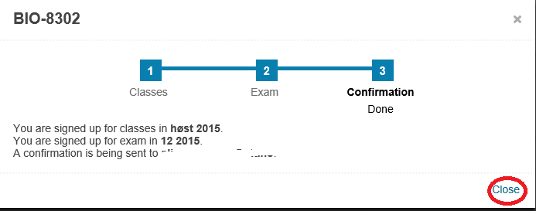

Stage 4: Editing after registration for classes and exams

Active courses

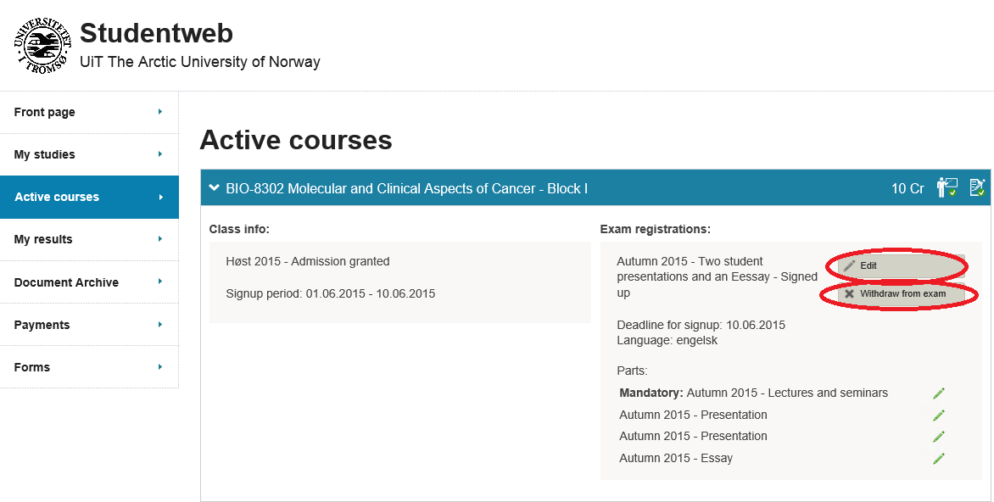

Edit

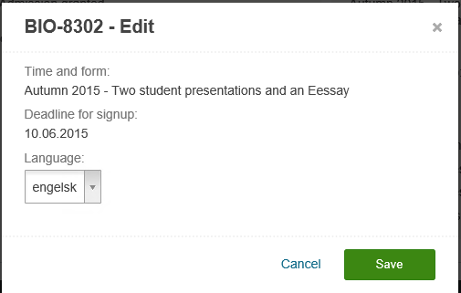

Do alterations
Click save

Withdraw from exam

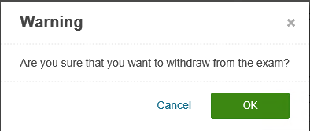

Click ok

