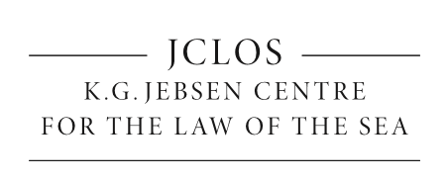
Expert Meeting on Good Governance and the Arctic
K.G. Jebsen Centre for the Law of the Sea, The Arctic University of Norway (UiT)
Arctic Frontiers Side Event
The Expert Meeting on Good Governance and the Arctic offers an interdisciplinary overview of the good governance tools applied to the Arctic with a specific focus on the role of indigenous peoples’ participation in environmental decisions. Keynote speakers will be international scholars in the fields of law, humanities and social sciences. The initiative is part of a postdoctoral project funded by the K.G. Jebsen Centre for the Law of the Sea, whose focus area covers, inter alia, the protection of the Arctic marine environment.

Venue: UiT
Date & Time: 26 January 2017, 13.00-15.00
Opening remarks Tore Henriksen, Elise Johansen, Margherita Poto
13.10-13:25 Lena Schøning (UiT) – Good governance tools: A lesson from corporate law
13.25-13.40 Lara Fornabaio (UniFe) and Margherita Poto (UiT) – Fathoming the depths of global Governance: a lesson from the Arctic Council
13.40-13:55 Piotr Graczyk (UiT) – Good governance and the Arctic Council: the perspective from social sciences
13.55-14:10 Timo Koivurova, (University of Lapland) – Participatory Rights of Indigenous Peoples in the Arctic Council
14:10-14:25 Leena Heinämäki (University of Lapland) – From consultation to consent? Current legal status of FPIC of Indigenous Peoples
14.25-14:40 Dorothée Cambou (NIEML-Arctic Center) – The right to "supranational self-determination": the emergence of a new right for Indigenous Peoples in the Arctic region?
14:40-14:55 Carol Cravero and Roberto Caranta (University of Turin) – Empowering indigenous communities through sustainable public procurement: challenges and best practices
Concluding remarks Margherita Poto
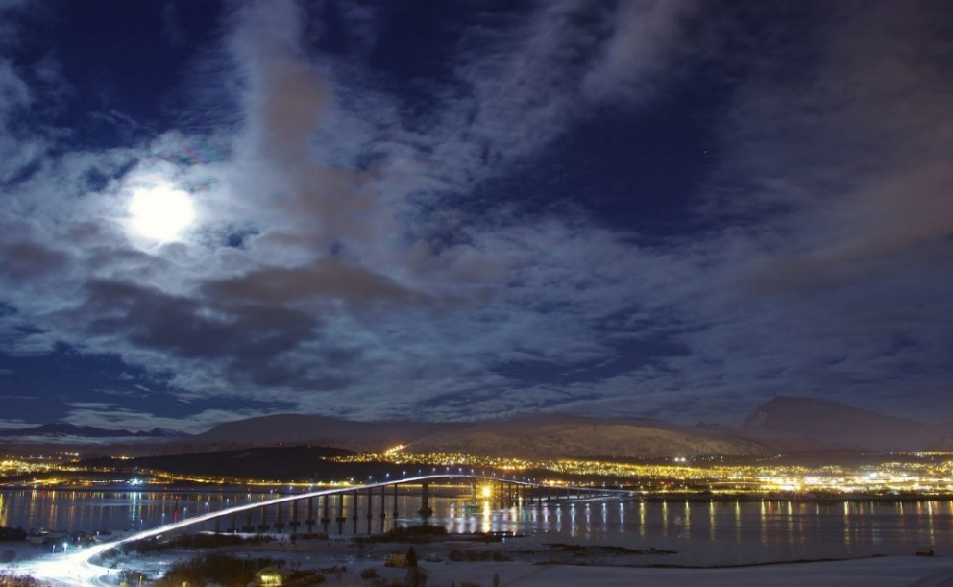
Photo: Bo Eide

