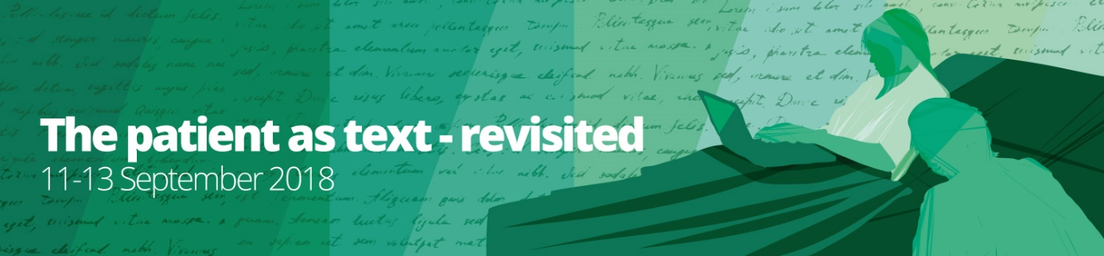

Program:

Tuesday 11.09.
09:45-10:00: Coffee and registration
10:00-10:15: Opening and welcome (Linda Nesby and Johs. Hjellbrekke)
10:15-11:00: Opening keynote lecture: Jens Brockmeier: I don’t really know what happened but I can tell you this…: Multiple experiences and the act of narrating

11:00-11:30: Coffee

11:30-13:00: Session 1: Historical medical humanities
Paula Ryggvik Mikalsen: Reading as Illness in Jane Austen’s Northanger Abbey
Silje Warberg: Medical discourse in c19 literary criticism
Cathinka Dahl Hambro: Ecstatic Pain: Julian of Norwich’ Revelations of Divine Love as Pathography

13:00-14:30: Lunch

14:30-15:30: Session 2: Literature and madness
Ingri Løkholm Ramberg: The Patient as homo sacer: A study of the seclusion in Amalie Skram’s Professor Hieronimus
Fredrik Parelius: Negotiating madness in Olav H. Hauges «Eldberget» (1951)

15:30-16:00: Coffee

16:00-17:00 Session 3: Illness and otherness
Hanne Bess Bolsbjerg: Narrating differences – understanding the stories of patients with ethnic minority background
Nora Simonhjell: Included, but still not heard?

19:30: Conference dinner

Wednesday 12.09.
10:00-10:45: Keynote speaker: Matías Martínez: True? Authentic? Reliable? On Truth Claims in Illness Narratives

10:45-11:15: Coffee

11:15-12:45 Session 4: Medicine and literary aesthetics
Anders Juhl Rasmussen: Close reading as enchantment – in Narrative Medicine
Linda Nesby and May-Lill Johansen: Shock and everyday life. Reading Paul Kalanithi’s When breath becomes air by Rita Felski
Katarina Bernhardsson: The patient and the reader: intertextuality and reader connection

12:45-14:00 Lunch

14:00-15:00: Expressing illness
Sandra Goldbeck-Wood: When bodies speak and words act – poetry and the lost art of medicine
Cindie Aaen Maagaard: Resisting coherence through narrative form: Productive tensions in illness narratives

15:00-15:30: Coffee

15:30-17:00: Session 6: Medical humanities and cancer
Soledad Pereyra: The writer as a patient with a brain tumor: A comparative study
Christian Lenemark: Representing and Comprehending the Illness Experience: Cancer Narratives in Digital Media
Helle Ploug Hansen and Anders Juhl Langscheidel Rasmussen: Creative writing workshops for people with a cancer disease

Thursday 13.09.
10:00-ca. 12:00: Session 7: Literature and mental illness
Lise-Mari Lauritzen: Narrative empathy in contemporary novels about mental illness
Lasse Gammelgaard: Chaos narrative and Experientiality in Graphic Memoirs about Mental Illness
Cecilia Pettersson: Motherhood and taboo in contemporary autobiographies about postpartum depression

Closing remarks by Petter Aaslestad and end of conference remarks by Linda Nesby and Cathinka Dahl Hambro

12:00: Lunch

Practical information
The symposium will take place at Centre Universitaire de Norvège à Paris (CUNP)
Salle B1-1
Lunches will also be at CUNP
From the Pantheon-area to CUNP, walk through Le Jardin de Luxembourg, rue Vaugirard, rue d’Assas, and you will find CUNP on your left-hand side opposite Hôtel Lutecia. Ca. 20 min.
The participants will have to order flight tickets etc. and accommodation themselves. The following hotels are near the Pantheon, which is convenient, both when it comes to transport to the airport, CUNP and the restaurant for our conference dinner. Senlis is most budget friendly, while Select is most expensive. The delegation from UiT The arctic university of Norway will be at Hotel des 3 colleges.
** L'Hôtel de Senlis
7-9, rue Malebranche
75005 Paris
tél.0033(0)143299310
www.hoteldesenlis@wanadoo.fr<http://www.hoteldesenlis@wanadoo.fr>

** Hotel des 3 collèges
16, Rue Cujas
75005 Paris
tél. 0143546730
hotel@3colleges.com<mailto:hotel@3colleges.com>

** Hôtel du Brésil
10, rue Le Goff
75005 Paris
tél.0033(0)143547611
hoteldubresil@wanadoo.fr<mailto:hoteldubresil@wanadoo.fr>

** Hotel Excelsior Latin
20 rue Cujas
75005 Paris
tél. : +33 (0)1 46 34 79 50
excelsior5@orange.fr<mailto:excelsior5@orange.fr>

***Hôtel Design de la Sorbonne
6, Rue Victor Cousin, 75005 Paris
01 43 54 58 08

Hotel Cujas Pantheon
18 Rue Cujas,
75005 Paris
hotel-cujas-pantheon@wanadoo.fr<mailto:hotel-cujas-pantheon@wanadoo.fr>

*** Select Hôtel
1, Place de la Sorbonne
75005 Paris
tél. 0146341480
www.selecthotel.fr
selecthotel05@gmail.com<mailto:info@selecthotel.fr>

TRANSPORT:
From the airports to the hotel Hotel des 3 Collèges:
Take RER B train (ca 10 eur) to Luxembourg, the hotel is 2-3 minutes’ walk away.
Taxi from Orly 30 eur, from Charles de Gaulle 55 eur, fixed prices.
(We suggest you have some euros in cash, not all taxis take credit cards).
Directeur Johs HJELLBREKKE
johs.hjellbrekke@msh-paris.fr
Responsible administrative Kirstin B. SKJELSTAD
skjelsta@msh-paris.fr

