“11th Polar Law Symposium”
Troms, October 2 – 4 2018

Symposium Hotel: Clarion Hotel The Edge

Travel from the airport:
The airport express coach stops at several hotels in central Tromsø. Travel time is approximately 10 – 15 minutes to Tromsø city center. The buses are located outside the arrival hall.
The taxi stand is also located directly outside the arrival hall. Travel time to city center is approximately 10 minutes.

Conference venue:
UiT The Arctic University of Norway, The Law Faculty, Teorifagbygget, houses 1 and 4.
Auditorium 2 in house 1 and room 4.213 in house 4.
All plenary sessions will be in auditorium 2, house 1.
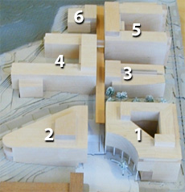
Map over the University campus.

Bus transport to from the University
Bus transport is provided to/from the University/City Centre.
The bus stop will be close to Hotel The Edge and Tromsø Havn (The port of Tromsø).
Christin Skjervold will meet at the front desk of the hotel at 0800 on Tuesday 2 October. If you are not staying at hotel the Edge, you can meet there for the bus.

Dinner Tuesday 2 October:
We have the pleasure of inviting you for dinner at 1900hrs Tuesday 2 October. The dinner will be at Clarion Hotel The Edge.
Please provide Christin Skjervold with information regarding any dietary needs.

The LLM Reception 3 October:
We will proceed immediately from the LLM panel session to the reception. The venue is Solhallen, which is located outside auditorium 2.
No special dress code is required.

Payment of conference fee:
As many of you already have noticed, it is not possible to pay by credit card or cash. Please, transfer the conference fee by using the following information:
Sparebank1 Nord-Norge, PoBox 6800, N-9298 Tromsø, Norway
BIC/SWIFT: SNOWNO22
IBAN: NO59 4714 10 01236
The payment must be marked: 470032 Polar Law Symposium
Account holder: UiT The Arctic University of Norway

