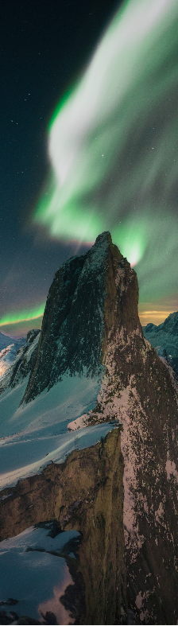
Program

Kick-off Aurora Outstanding

Class 2020-2022
Time: Jan 11th 2021 11:30 – 14:00
Place: UiT TEO H6, Champagnekantina/Sjampanjekafeen
11:30 – 12:10 | Photography (profile pictures with individual time slots) + light food
12:15 – 13:15 | - Music by Julie Alapnes  - Welcome by rector Anne Husebekk  - About Aurora Outstanding program by Theresa Mikalsen and Inger Lin Uttakleiv Ræder  - Experience from Aurora Outstanding 1st class (2018-2020) by Eva-Stina Edholm and Juha Vierinen  - Music by Julie Alapnes
13:15 – 14:00 | Photography (incl. group picture) + light food

